Rh Incompatibility

Table of Contents
Rh Incompatibility 1
Introduction to Rh incompatibility 3
Rh Factor 3
Rh Incompatibility 3
Diagnostic / laboratory tests: 5
Clinical manifestations 5
More severe forms / conditions 6
Hydrops Fetalis 6
Icterus Gravis Neonatorum 6
Congenital Anaemia 7
Treatment 7
Additional preventive/management: 7

Introduction to Rh incompatibility
Rh incompatibility occurs when a pregnant woman who is Rh negative is carrying a baby who is Rh positive. During pregnancy or delivery, the baby’s blood can enter the mother’s bloodstream and cause her to produce antibodies against the Rh positive blood. These antibodies can then cross the placenta and destroy the baby’s red blood cells, causing hemolytic disease of the newborn.
To prevent sensitization, Rh negative mothers are given Rh immunoglobulin during and after pregnancy to prevent production of antibodies against Rh positive blood. Failure to prevent sensitization can lead to jaundice, anemia, heart failure or even death for an Rh positive baby in subsequent pregnancies.

Rh Factor

The Rhesus factor gets its name from experiments conducted in 1937 by scientists Karl Landsteiner and Alexander S. Weiner. Their experiments involved rabbits which, when injected with the Rhesus monkey’s red blood cells, produced an antigen that is present in the red blood cells of many humans.

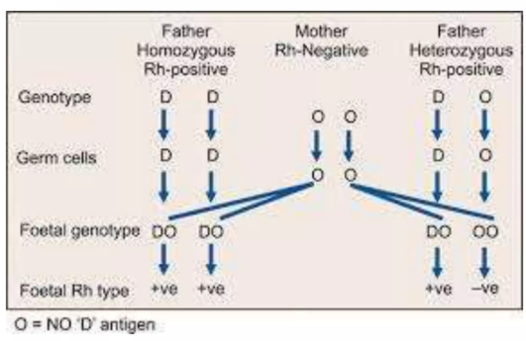
Rh Incompatibility

Rh incompatibility is a condition which develops when there is a difference in Rh blood type between the pregnant mother (Rh negative) and the fetus (Rh positive).
A person’s Rh type is generally most relevant in pregnancies.
- If the pregnant woman and her husband are both Rh negative, there is no risk of Rh incompatibility.
- If the mother is Rh negative and the husband is Rh positive, the baby may inherit the father’s Rh positive type, creating incompatibility.
If some of the fetal blood enters the mother’s bloodstream, her body may produce antibodies. These antibodies could cross back through the placenta and harm the developing baby’s red blood cells.
Normally the placenta acts as a barrier to fetal blood entering maternal circulation. However, sometimes during pregnancy or birth, fetomaternal hemorrhage occurs. The woman’s immune system responds by producing anti-D antibodies, causing sensitization.
The difference in blood type between mother and baby causes Rh incompatibility only when the mother is Rh negative and baby is Rh positive.
Sensitizing events include:
- A previous pregnancy
- An ectopic pregnancy, miscarriage, or induced abortion
- A mismatched blood transfusion or stem cell transplant
- An injection, puncture, or injury involving Rh positive blood
In the first pregnancy, if father is RhD+ and mother is RhD–, the fetus may be RhD+. During labour, fetal–maternal blood transfer may occur. The first baby may be safe, but the mother then becomes sensitized to the RhD antigen.

In a second pregnancy, the mother responds rapidly by producing IgG anti-D. Maternal IgG anti-D crosses the placenta, binds to fetal red blood cells, and marks them for destruction → fetal/neonatal hemolytic anemia; increased bilirubin; CNS damage (kernicterus); possibly death.

Diagnostic / laboratory tests:
- Kleihauer–Betke test or flow cytometry
- Indirect Coombs test
- Direct Coombs test
- Blood count
- Bilirubin (direct & indirect)

Clinical manifestations
Clinical manifestations vary from mild to severe. Some listed are:
- Hemolysis
- Jaundice
- Generalized swelling (total body swelling)
- Respiratory distress
- Circulatory collapse
- Kernicterus
- These may occur several days after delivery; signs include poor feeding, decreased activity

More severe forms / conditions
- Hydrops fetalis
- Icterus gravis neonatorum
- Congenital anemia of newborn
- In the most severe form, excessive destruction of fetal red cells leads to severe anemia, tissue anoxia, metabolic acidosis
- In less severe, the baby may be born alive without jaundice but develops it within 24 hours
- In very mild forms, hemolysis occurs slowly, and anemia develops over weeks
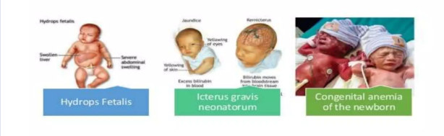


Hydrops Fetalis
This is a most serious form of Rh haemolytic disease. Excessive destruction of the fetal red cells leads to severe anaemia, tissue anoxaemia and metabolic acidosis

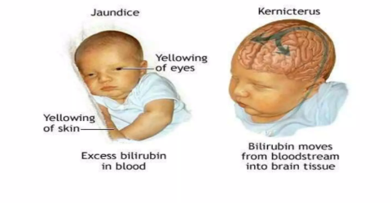
Icterus Gravis Neonatorum
This clinical entity is the effect of lesser form of fetal haemolysis. The baby is born alive without evidence of jaundice but soon develops it within 24 hours.

Congenital Anaemia
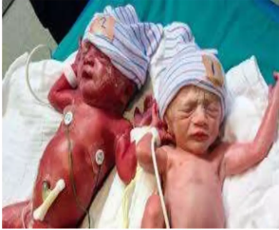
Mildest form of diseases where the haemolysis is going on slowly. Although anemia develops slowly within the first few weeks

Treatment
- The main preventive treatment is administration of Rh immunoglobulin
- For a baby with hemolytic anemia, treatment depends on severity
- If Rh incompatibility is diagnosed during pregnancy, mothers are given Rh immunoglobulin around the 7th month and again within 72 hours postpartum
- Mothers may also receive Rh immunoglobulin in situations with increased risk of fetal–maternal bleeding (miscarriage, ectopic pregnancy, bleeding episodes)

Additional preventive/management:
- Immunization with Rh immunoglobulin helps prevent or minimize fetal–maternal bleeding
- Prevent mismatched transfusions
- Amniocentesis should only be done after localizing the placenta via ultrasound

